Java MySQL Create, Read, Update, Delete (CRUD) Project
1. First, create a new database named 'crud' in MySQL. Then create a table named 'user'.
USE crud;
CREATE TABLE user (
sl_no INT(5),
name VARCHAR(100),
email VARCHAR(100)
);

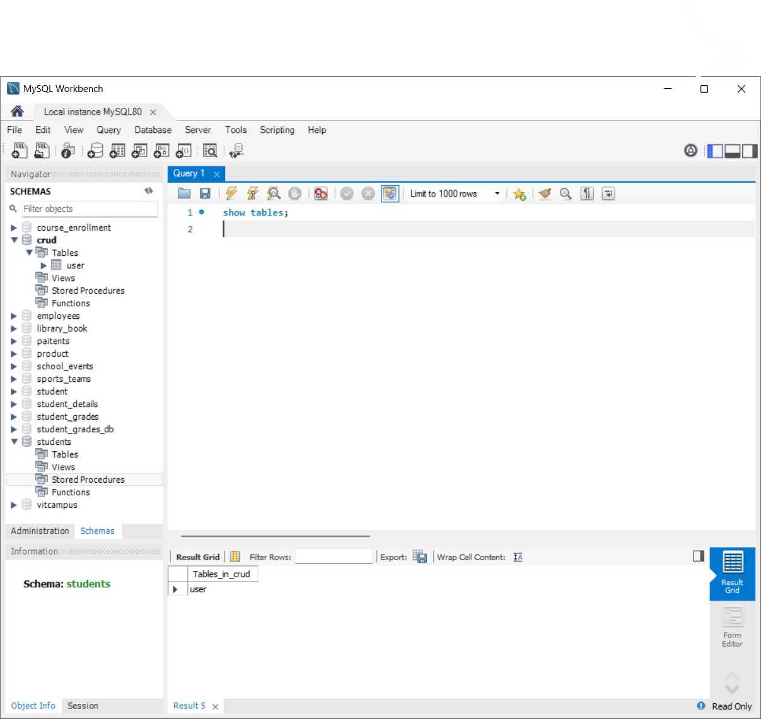

2. Project Structure in Eclipse IDE:-
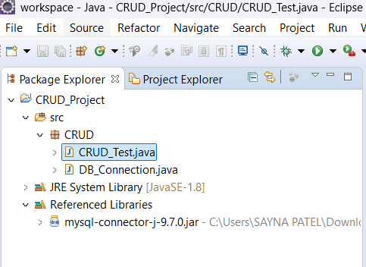

3. Connection Class to Get Connection with MySQL
DB_Connection.java
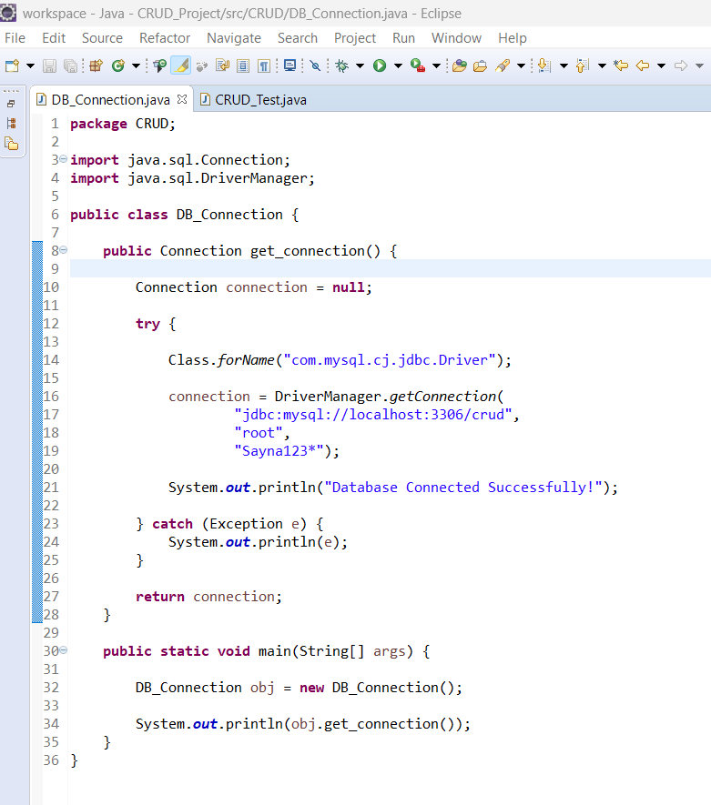

CRUD Operations :-
1. CREATE (Insert) :-
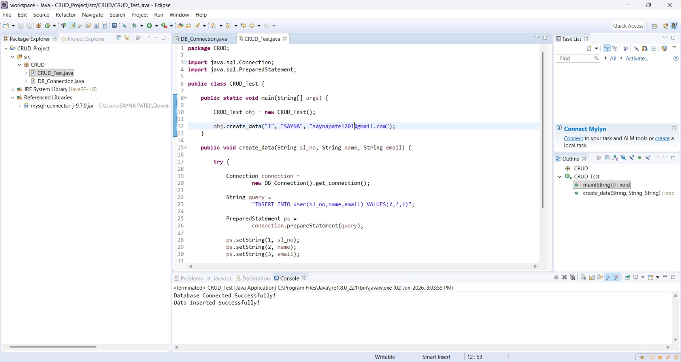
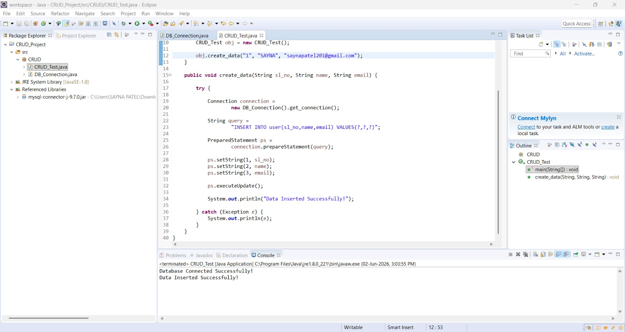
In MySQL :-
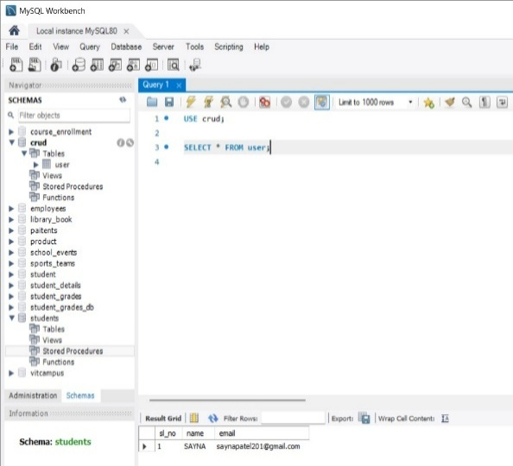

2. READ :-
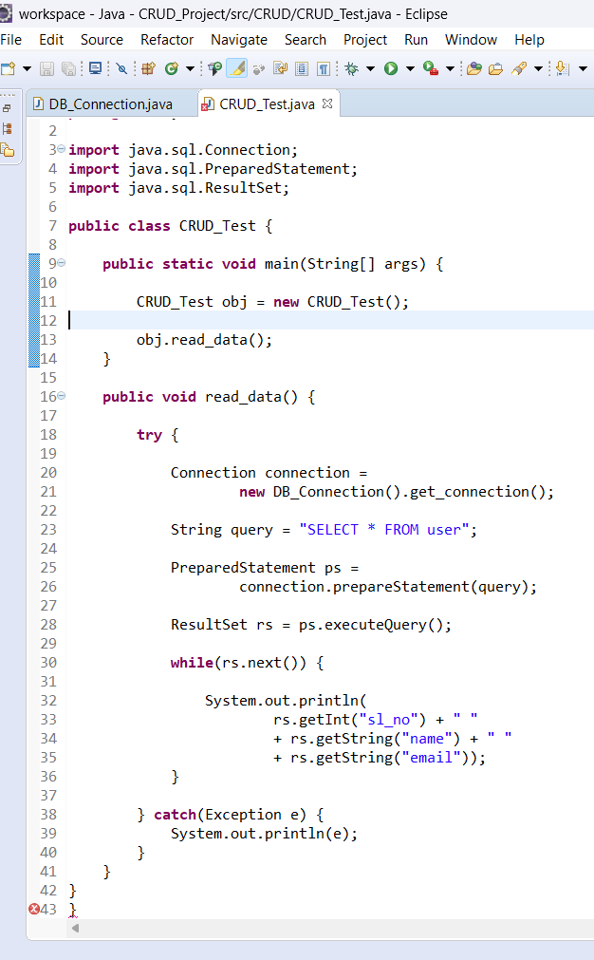
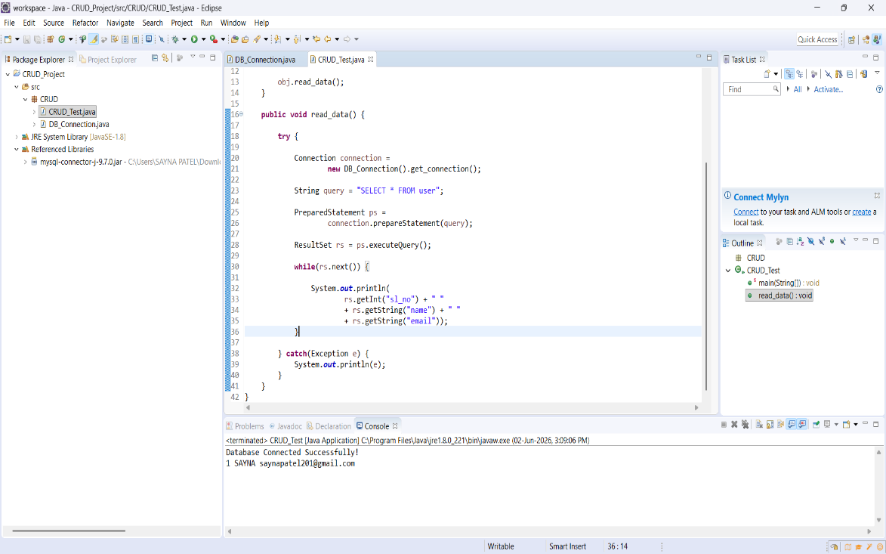

3. UPDATE :-
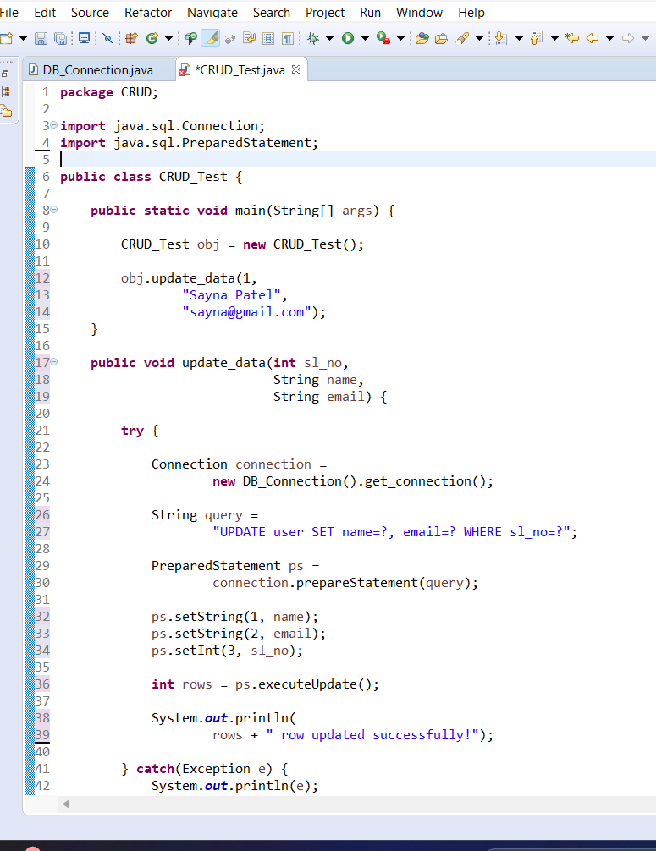
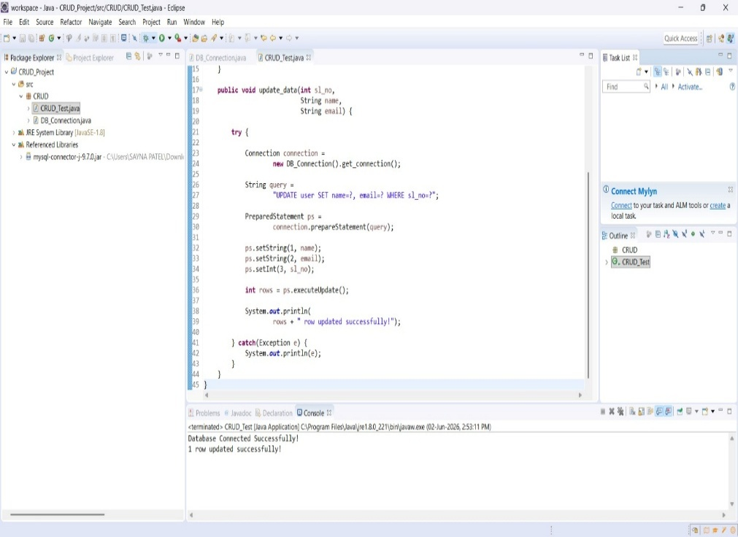
In MySQL :-
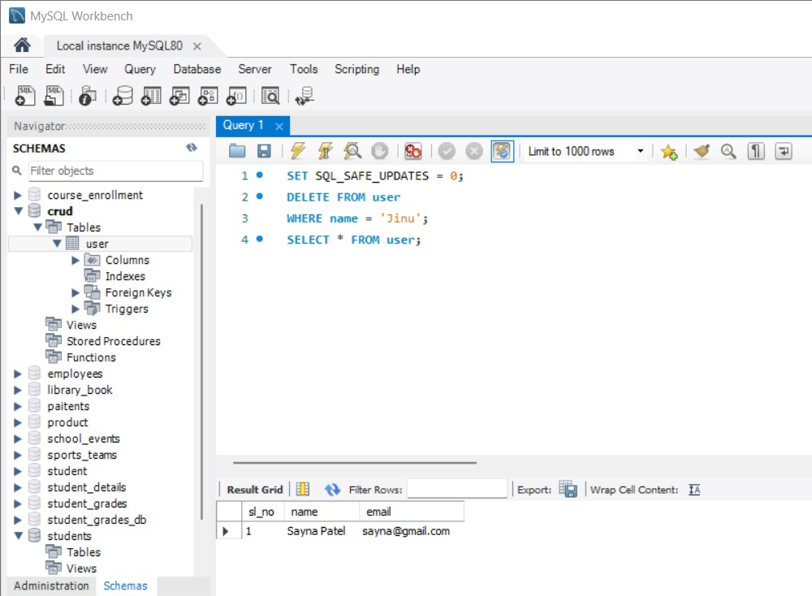

4. DELETE :-
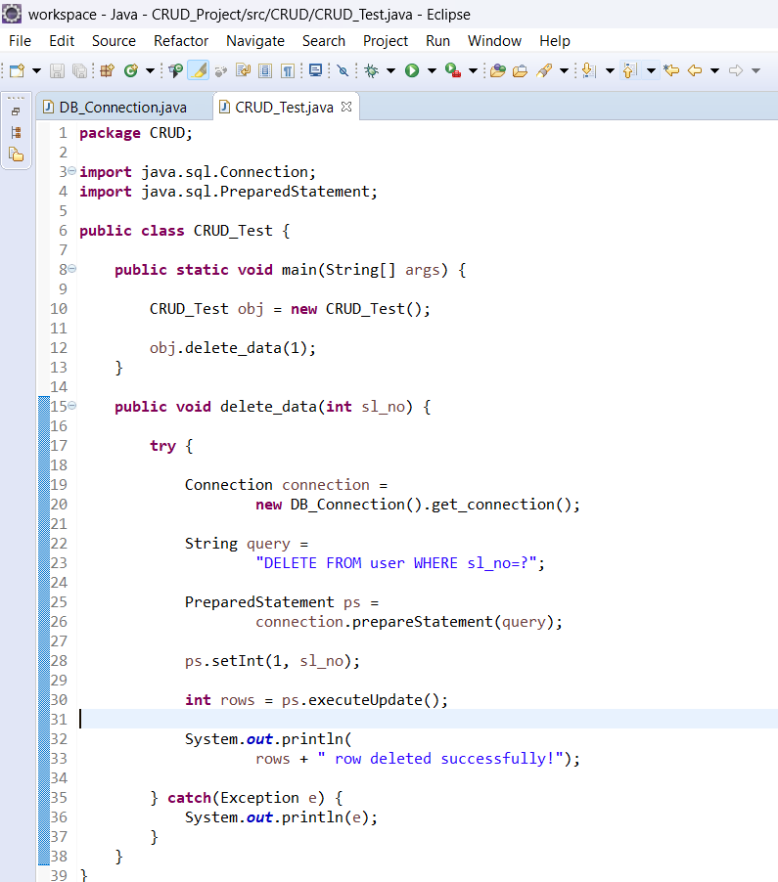
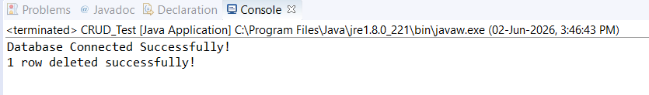
In MySQL:-
